# **Name: Abdurrahman Qureshi**

# **Roll No: 210451**

Practical No: 13

**1)** **Write a program to demonstrate the use of WindowAdapter class**

**CODE:**

import javax.swing.*;  
import java.awt.event.*;   
public class Main {  
 public static void WindowAdapterDemo() {  
 JFrame frame = new JFrame("WindowAdapter Demo"); frame.setDefaultCloseOperation(JFrame.*EXIT_ON_CLOSE*);  
 frame.setSize(300, 200);  
 frame.addWindowListener(new WindowAdapter() {@Override  
public void windowOpened(WindowEvent e{  
 System.*out*.println("Window opened."); }@Override  
public void windowClosing(WindowEvent e{  
 System.*out*.println("Window closing."); } @Override public void windowClosed(WindowEvent e) {  
 System.*out*.println("Window closed."); } @Override  
public void windowIconified(WindowEvent e) { System.*out*.println("Window iconified (minimized)."); }@Override public void windowDeiconified(WindowEvent e) {  
System.*out*.println("Window deiconified (restored)."); } });  
 JButton closeButton = new JButton("Close Window");  
 closeButton.addActionListener(new ActionListener() {@Override  
public void actionPerformed(ActionEvent e) {frame.dispose();}});  
 frame.add(closeButton);  
 frame.setVisible(true); }  
 public static void main(String[] args) { *WindowAdapterDemo*();}}

**OUTPUT:** 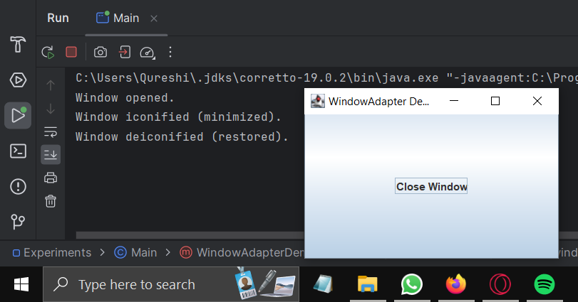

**2) Write a program to demonstrate the use of anonymous inner class**

**CODE:**

import javax.swing.*;  
import java.awt.*;  
import java.awt.event.ActionEvent;  
import java.awt.event.ActionListener;  
  
public class Main {  
 public static void AnonymousInnerClassDemo() {  
 JFrame frame = new JFrame("Anonymous Inner Class Demo");  
 frame.setDefaultCloseOperation(JFrame.*EXIT_ON_CLOSE*);  
 frame.setLayout(new FlowLayout());  
  
 JButton clickMeButton = new JButton("Click Me");  
  
 clickMeButton.addActionListener(new ActionListener() {  
 @Override  
 public void actionPerformed(ActionEvent e) {  
 JOptionPane.*showMessageDialog*(frame, "Button Clicked!");  
 }  
 });  
  
 frame.add(clickMeButton);  
 frame.setSize(300, 150);  
 frame.setVisible(true);  
 }  
  
 public static void main(String[] args) {  
 *AnonymousInnerClassDemo*();  
 }  
}

**OUTPUT:**

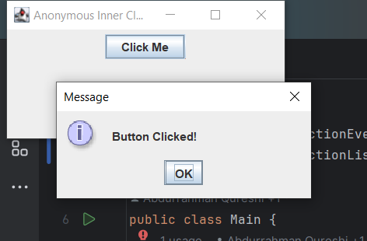

**3)** **Write a program using MouseMotionAdapter class to implement only one method mouseDragged().**

**CODE:**

import javax.swing.*;  
import java.awt.*;  
import java.awt.event.MouseAdapter;  
import java.awt.event.MouseEvent;  
  
public class Main {  
 public static void MouseDraggedDemo() {  
 JFrame frame = new JFrame("Mouse Dragged Demo");  
 frame.setDefaultCloseOperation(JFrame.*EXIT_ON_CLOSE*);  
 frame.setLayout(new BorderLayout());  
  
 JPanel panel = new JPanel();  
 panel.setPreferredSize(new Dimension(400, 300));  
  
 panel.addMouseMotionListener(new MouseAdapter() {  
 @Override  
 public void mouseDragged(MouseEvent e) {  
 // Implement the behavior for mouse dragged event  
 int x = e.getX();  
 int y = e.getY();  
 System.*out*.println("Mouse Dragged: (" + x + ", " + y + ")");  
 }  
 });  
  
 frame.add(panel, BorderLayout.*CENTER*);  
 frame.pack();  
 frame.setVisible(true);  
 }  
  
 public static void main(String[] args) {  
 *MouseDraggedDemo*();  
 }  
}

**OUTPUT:**

